BF9100 FM Car Radio Walkie Talkie
User Manual
- Features and Functions
This radio is aesthetic, firm, durable, high performance, perfect for all. The Ham FM Car Radio Walkie Talkie is design elaborately by Baofeng Team for the riders. It has the following features:
- Mini size, rational layout buttons and knobs, easier to operate
- High quality component and advanced technology with good heat dissipation materials to ensure long-term stability of the machine work
- Up to 20 memory channels available for programming frequencies and other various data
- Max RF output power 15W
- Frequency range: UHF 400-420MHz (optional 450-470MHz)
- The function of car station and the handset connected to the automatic synchronization
- The function of Intercom station with the phone off the car, or emergency call
- Dual-channel standby (current channel programmable, frequency designated emergency channel)
- Dual-channel call (current channel programmable, frequency designated emergency channel)
- Incorporate 104 codes "CDCSS" and 50 privacy codes "CTCSS" programmable, support for non-standard tone
- 5V DC output, convenient to connect automobile data recorder and mobile devices

- Notes:
Please observe the following precautions to prevent other accident damage to Walkie Talkie
- Don’t configure the unit while driving, it is too danger to do it.
- When driving on public roads, please note the headphones / headset using relevant local laws. If you are unsure, don’t wear headphones while driving.
- Don’t prolonged exposure walkie-talkie to direct sunlight, and don’t place it near a heating device.
- Don’t expose the radio to direct sunlight over a long time, nor place it close to heating source.
- If any unusual smells or smoke intercom, immediately turn off the power to the intercom, and contact the dealer or service station.
- The radio is designed to use 13.8V power supply, do not use 24V battery power.

- Unpacking and Checking Equipment:
Carefully unpack the transceiver. We recommend that you identify the items listed in the following before discarding the packing material. If any items are missing or have been damaged during shipment, please contact your dealers immediately.
9100 Car Frame | 1 |  | Handset | 2
Car Frame Antenna | 1 |  | Belt Clip | 2
Sucker Feeder | 1 |  | USB_MINI Cable | 2
Extension Access Line | 1 |  | lanyard | 2
Car Frame Hand Microphone | 1 |  | Earphone | 2
Fixed Support | 1 |  | BL-9100 Rechargeable Battery | 2
DC Cable | 1 |  | 13.8V Car Frame Adapter | 1
Install Screw Package | 1

- Installation of Car Frame
When installing the interphone, please choose safe and convenient location, to avoid in the process of vehicle dangerous for passenger and yourself in the car furthest. When selecting the installation position of the machine, it also need to take care of the knee and leg when the car scram and won’t crash the interphone.
- Use random provide self-tapping screws (4), flat washer (4), and the spring washer (4) to install mount support in the car.
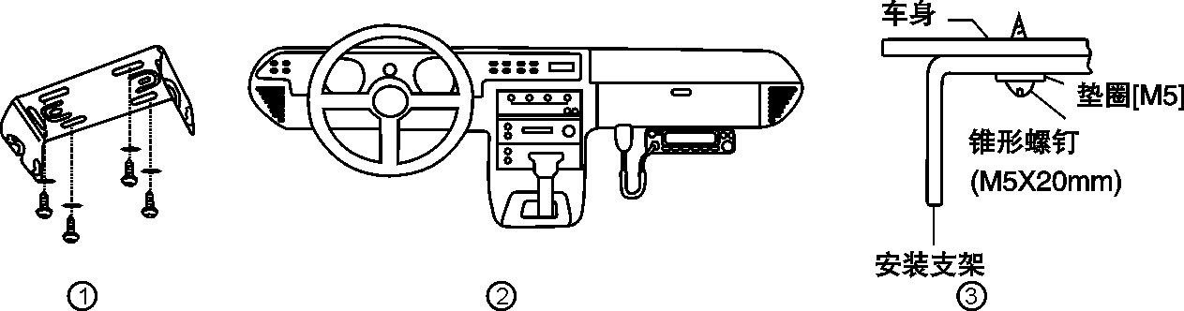
- Put the intercom well, insert and tighten the random of hexagonal SEMS screw washer (4) and flat washer (4).
Carefully check to ensure that all screws are tightened, avoid the bracket and interphone loosed by vehicle vibration.
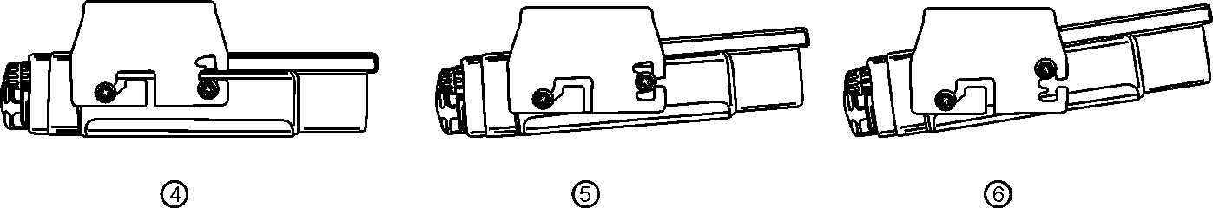
Use the three screw holes on the side of the bracket to ensure the proper angle of the interphone.
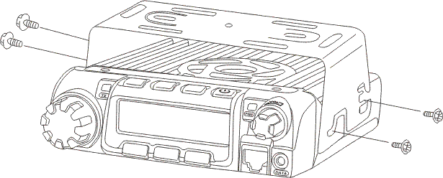

- Installation of accessories
- Installing the antenna
Before operation, please first install the random low loss of 50 Ω coaxial feeder, to match with the input impedance of the interphone.
Insert the random antenna into the antenna port, and screw the antenna nut.
- Inserting car charger adapter
Insert the random car charger adapter, into the panel DC IN power input interface (note: insert the random car charger adapter, into the panel DC IN power input interface). Advice on equipment installation is complete and check without problem to insert the car charger adapter and electric work.
△If for a fixed mode, please use the special DC line of random current (2A).
- Connection of handset and car frame
Use random extension access line to connect car frame and handsets in order to change the car frame work channel, frequency, and function of relay operation.
- Access to the headset or hand microphones
Insert the random special earphone or hand microphones headphone jack, when there is no handset connection, can be directly use headphones and microphones PTT button to implement launch functions. Release PTT button, and receive the other side of the call.
- DC 5V output power
When the automobile data recorder, power bank, mobile phone and other charging equipment need to charge, it can connect the USB cable to the interface to supply electricity for these equipment.

- Familiar with the Interphone
Former Panel
1 | Handset Port | It will synchronize data when the handset access，EXTN light shining；the handset display shake hand icon
2 | Earphone Port | External headset or hand microphones. When it does not insert extension, insert the headset or hand to achieve talkback function
3 | TX Light | Emission light, car frame is in emission condition, the light shining
4 | RX Light | Reception light, car frame is in reception condition, the light shining
5 | EXTN Light | Handset reception light, insert the handset, the light will shine when self-synchronizing
6 | SOS Button | Push down this button, the emergency channel in the launching state, and the SOS lights up
7 | POWER/VOL Rotary Knob | The power switch and volume control switch

Latter Panel
1 | DC Power Input Interface | Input 13.8V dc current (when car frame using need the specified car charger adapter)
2 | SP（Speaker）Jack | If necessary, connect optional external speaker here, get more clear sound effects. This jack for 3.5 mm mono (double wire) plug.
3 | DC5V Output Interface | Output DC5V power, can provide DC for mobile phone, automobile data recorder, etc.
4 | Antenna Interface | To connect the external antenna here. When test launch, to connect a dummy load here in lieu of antenna. The impedance of the antenna or load should be 50 Ω

- Basic Operation
- Vehicular-locating Open & Close
Clockwise turn the knob of the【POWER/VOL】 until you hear "clicking" sound, knobs in the green light will light.
△If you need to turn it off, please rotate counterclockwise this button until you hear "clicking" sound. Green light will put out.
- Adjust Volume
- Clockwise turn the knob of the【POWER/VOL】to improve the output volume
- Rotate counterclockwise to lower volume
- Call (emission)
- Switch in handset mode
It will synchronize data when the handset access，EXTN light shining；the handset display shake hand icon
If you want to call or launch, press down【PTT】button, put it from the mouth for about 5 m, and talk to the MIC normally. After speaking, loosen the button 【PTT】, and receive.
- Stand-alone mode (hand microphones or headset mode)
(doesn't insert the headset) Insert the earphone or hand onamot, push the hand onamot or earphone's【PTT】button, speak into MIC in a normal voice. Finished speaking, loosen your hand onamot of【PTT】for reception.
Note: Under single mode, the working frequency is the manufacture frequency or the last time of the handset insert channel.
- SOS Emergency Channel Call
By writing software rival degraded into SOS emergency channel frequency (receive frequency and transmission frequency).If encounter emergencies, can choose car SOS button for emergency calls.
- Pick up of handset mode, press the SOS button to call, SOS light on the front panel will light, speak to handset microphone; release button, and receive the other side of the call.
- Under single mode, holding down the car panel of SOS button, speak to the earphone; release button, and receive the other side of the call.
- Change working channel
Under the handset mode, change the working channel by / buttons, car frame and headset will be self-synchronizing to change the working channel.
-TECHNICAL SPECIFICATION:
Antenna impedance: 50Ω.
Operating temperature: -20 ° C to +60 ° C.
Supply voltage: DC13.8V 2A
Consumption in transmission: ≤2.2 A.
RF power: 15W.
Type of modulation: FM.
Emission class: 16KΦF3E/11KΦF3E (W/N).
Dimensions: 128mm x 120mm x 26mm
Weight: 130 g (approximate).

Note:
- All specifications shown are subject to change without notice.

